**Case Study – stylish low-rise apartment complex designed by Architects Australia (7x 2 bedroom apartments and 1x 3 bedroom apartment) Builder – Contrast Constructions.**

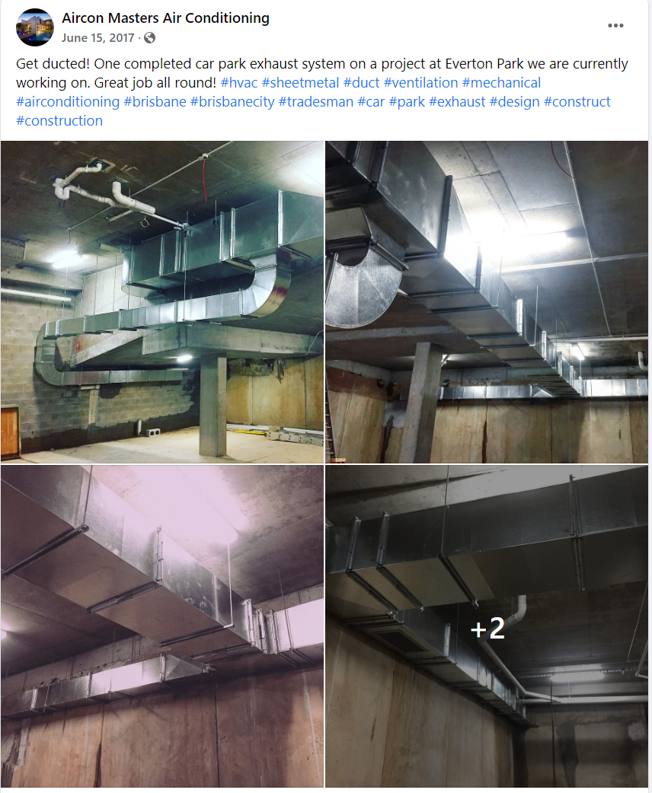**We installed ActronAir split multi-heads into each apartment as well as supplied and installed the carpark ventilation system.**